**DEERWALK INSTITUTE OF TECHNOLOGY**

**Tribhuvan University**

**Faculties of Computer Science**

**Bachelors of Science in Computer Science and Information Technology (BSc. CSIT)**

**Course: Computer Graphics (CSC214)**

**Year/Semester: II/III**

**A Lab report on:**

**Implementation of Bresenham’ s Line Drawing Algorithm**

Submitted by:

Name: Parth Poudyal

Roll: 1317

Submitted to:

Binod Sitaula

Department of Computer Science

**Theory**

Brasenham’s line drawing algorithm:

As seen in the previous line drawing algorithm using DDA algorithm, we could find out that:

* Since we were working with floating point values, the lines produced while making a long line did not come out as smooth, and had stairs like pattern
* Floating point values made the calculations more complex thus required more time for calculations.

Therefore, to solve this problem, Bresenham line algorithm was introduced.

Here to note,

Bresenham line drawing algorithm stands out form DDA such that it only operates in integer point values, which makes the lines appear straight and make the calculations more complex.

In the beginning of the Bresenham’ s line drawing algorithm an initial decision parameter is taken.

Based on the values for decision parameters, the values of x-coordinates and y-coordinates are incremented, decremented or brought no change in the next (coming) iteration of the algorithm.

Like DDA , there are multiple cases for Bresenham’ s line drawing algorithm.

For $m≥1$: Initial decision parameter: $p_{0}=2∆x-∆y$

|  |  |
| --- | --- |
| For ( $p≥0)$ | For ( $p<0)$ |
| $$y_{i+1}=y_{i}+1$$ | $$y_{i+1}=y_{i}+1$$ |
| $$x_{i+1}=x_{i}+1$$ | $$x_{i+1}=x_{i}$$ |
| $$p_{k+1}=p_{k}+2∆x- 2∆y$$ | $$p_{k+1}=p_{k}+2∆x$$ |

For $m<1:$ $p_{o}=2∆y-∆x$

|  |  |
| --- | --- |
| For $(p≥0)$ | For $(p<0)$ |
| $$x_{i+1}=x_{i}+1$$ | $$x_{i+1}=x_{i}+1$$ |
| $$y_{i+1}=y_{i}+1$$ | $$y_{i+1}=y_{i}$$ |
| $$p_{k+1}=p_{k}+2∆y- 2∆x$$ | $$p_{k+1}=p_{k}+2∆y$$ |

Note:

If the initial coordinates are more than the final coordinates, the values for the coordinates in the particular coordinates axis must be decremented instead of increasing.

**Algorithm**

Step 1 : find the slope of form the given values of $\left(x_{0}, y_{0}\right)$ and $\left(x_{1}, y_{1}\right)$

$m=\frac{y_{1}-y_{0}}{x_{1}-x_{0}}$ $=\frac{∆y}{∆x}$

Step 2 : if the values of m is greater than or equal to 1:

Let initial decision parameter be p = $2∆x-∆y$

Steps = $∆y$

Else: initial decision parameter be p = $2∆y-∆x$

Steps = $∆x$

Step 3: for i = 0 to steps:

Print (x_i , y_i)

Case 1 : $m≥1$

Implement this:

|  |  |
| --- | --- |
| if ( $p≥0)$ | Else, |
| $$y_{i+1}=y_{i}+1$$ | $$y_{i+1}=y_{i}+1$$ |
| $$x_{i+1}=x_{i}+1$$ | $$x_{i+1}=x_{i}$$ |
| $$p_{k+1}=p_{k}+2∆x- 2∆y$$ | $$p_{k+1}=p_{k}+2∆x$$ |

Case 2 : $m<1$

Implement this:

|  |  |
| --- | --- |
| If $(p≥0)$ | Else, |
| $$x_{i+1}=x_{i}+1$$ | $$x_{i+1}=x_{i}+1$$ |
| $$y_{i+1}=y_{i}+1$$ | $$y_{i+1}=y_{i}$$ |
| $$p_{k+1}=p_{k}+2∆y- 2∆x$$ | $$p_{k+1}=p_{k}+2∆y$$ |

Step 4: STOP

**Program code:**

The Bresenham’ s line drawing algorithm has been implemented in a C++ program.

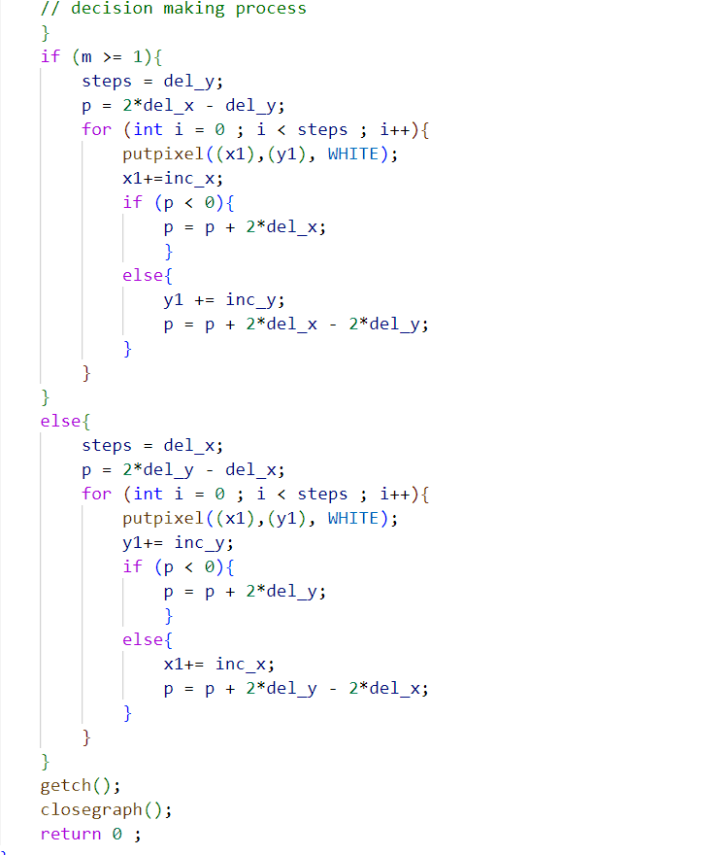

**Output**

Moving from Left to Right

Moving from Right to Left

**Conclusion**

From this project, we got to learn about yet another scan line algorithm; Bresenham’ s Line Algorithm. We saw how this algorithm was able to tackle the problem brought by the DDA line algorithm.

However, since this algorithm involves the process of determining the next step using a decision parameter, the procedure becomes more complex than the DDA.